**DAILY ONLINE ACTIVITIES SUMMARY**

|  |  |  |  |  |  |  |  |  |
| --- | --- | --- | --- | --- | --- | --- | --- | --- |
| **Date:** | **04-07-2020** | | | | | **Name:** | **Anix Jugal D’Cunha** | |
| **Sem & Sec** | **8 sem , A sec** | | | | | **USN:** | **4AL16CS013** | |
| **Online Test Summary** | | | | | | | | |
| **Subject** | | **Not Conducted** | | | | | | |
| **Max. Marks** | | **--** | | **Score** | | | **--** | |
| **Certification Course Summary** | | | | | | | | |
| **Course** | **Easy learning C++ for beginners** | | | | | | | |
| **Certificate Provider** | | | **Udemy** | | **Duration** | | | 5 hours |
| **Coding Challenges** | | | | | | | | |
| **Problem Statement:** Python3 program to rotate an array by d elements | | | | | | | | |
| **Status: Competed** | | | | | | | | |
| **Uploaded the report in Github** | | | | | **yes** | | | |
| **If yes Repository name** | | | | | **alvas-education-foundation/dcunhaanixjugal** | | | |
| **Uploaded the report in slack** | | | | | **yes** | | | |

Online Test Details: (Attach the snapshot and briefly write the report for the same)

**Not Conducted**

Certification Course Details: (Attach the snapshot and briefly write the report for the same)

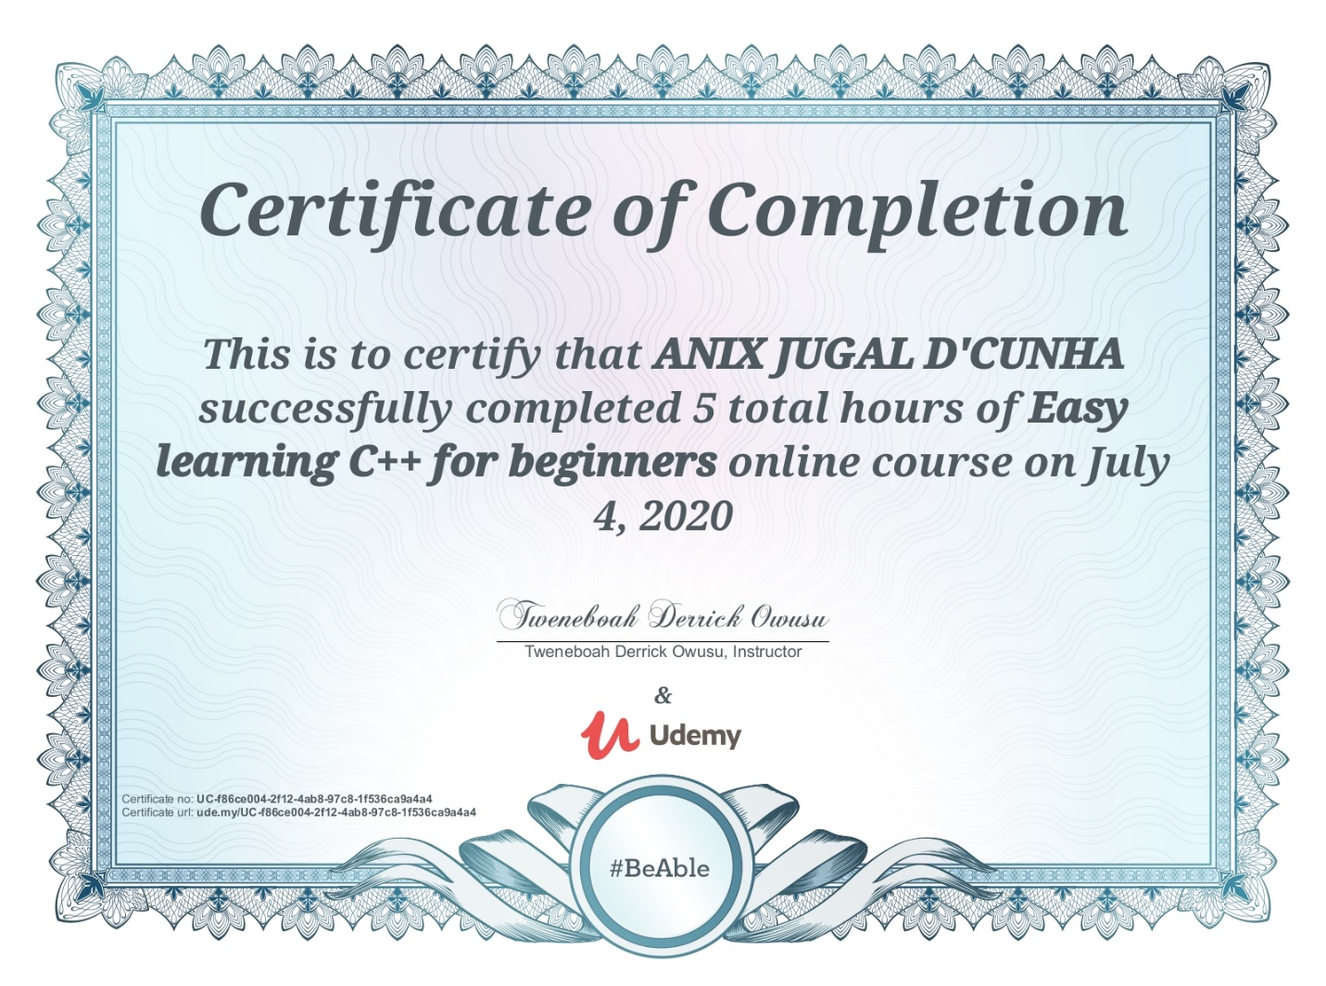

Coding Challenges Details: (Attach the snapshot and briefly write the report for the same)

## Program-> Python3 program to rotate an array by d elements

|  |
| --- |
|  |

## def leftRotate(arr, d, n):

## for i in range(d):

## leftRotatebyOne(arr, n)

## 

## def leftRotatebyOne(arr, n):

## temp = arr[0]

## for i in range(n-1):

## arr[i] = arr[i + 1]

## arr[n-1] = temp

## 

## 

## def printArray(arr, size):

## for i in range(size):

## print ("% d"% arr[i], end =" ")

## 

## arr = [1, 2, 3, 4, 5, 6, 7]

## leftRotate(arr, 2, 7)

## printArray(arr, 7)

## 

## Output:

## 3 4 5 6 7 1 2

## 